AUBURN INTERFAITH FOOD CLOSET, Inc.
12972 Earhart Ave. Suite 301
P. O. Box 132
Auburn, CA 95604
530-885-1921
www.auburnfoodcloset.org

Purchase Personalized Paver Bricks to Support the AIFC Building Campaign

Families, businesses and civic organizations can create long-lasting recognition of support for AIFC and its building campaign by purchasing paver bricks to be included in the AIFC Pathway of Recognition. This gift can also be a way to recognize special people in your life. These bricks will be used in the entrance area of our new building. Your contribution for these bricks may be tax deductible!

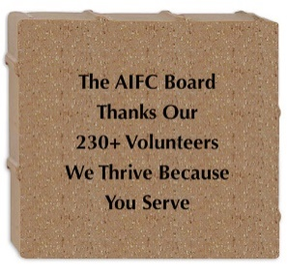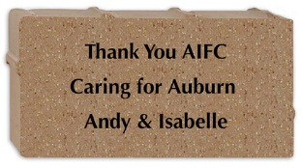
8” x 8” paver brick 4” x 8” paver brick 8” x 8” with logo or clip art
Six text lines Three text lines special order
20 characters each line 20 characters each line contact us for assistance
$230 each $125 each $230 + $tbd

- $10 discount per brick when 5 or more bricks are ordered
- $20 per brick to reserve premium location (limited number – 1st come, 1st serve)
- AIFC reserves the right to deny any brick donation application which it determines to be inappropriate by the stated or implied message.
- No addresses, phone numbers or websites allowed on bricks.

The Pathway of Recognition will be built into the walkways leading to the building and under the building portico, as well as the plaza area. Premium sites will be limited to high traffic sections of the walkway.

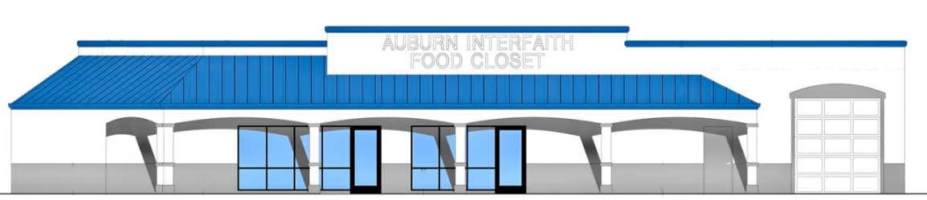
Building Location: 1788 Auburn Ravine Road

To order: Use the following 2-pages or go to: www.brickmarkersusa.com/donors/aifc.html
Order Assistance: Andy Hayes: 916-259-1358 / ach_igh@hotmail.com

Help AIFC Build Our New Facility

Auburn Interfaith Food Closet, Inc. is a 501 (c) (3) non-profit organization – FEIN 68-0424269

AIFC Pathway of Recognition Order Form

Name: ________________________________________________________________

Street Address: _________________________________________________________

City: ________________________________________ ST _______ Zip ____________

Phone: ___________________________ Email: ______________________________
I prefer you contact me by: Phone Email Either (circle one)

- Order:
Product |  |  |  | Unit Cost | Number |  | Line Cost
8” x 8” brick |  |  |  | $230
4” x 8” brick |  |  |  | $125
Volume Discount |  |  |  | $10 / brick
Clip art / logo |  |  |  | Special order
Premium Location |  |  |  | $20 / brick
 |  |  |  | Order Total
 |  |  | Contact me to discuss logo or clip art.
- Payment Method
 | Check enclosed – please make check payable to AIFC or Auburn Interfaith Food Closet
 | PayPal - www.brickmarkersusa.com/donors/aifc.html

- Create Your Message
Create your text layout for each brick in the spaces on the correct size matrix, located on the next page. Please use one matrix for each brick.
- AIFC reserves the right to deny any brick donation application which it determines to be inappropriate by virtue of the stated or implied message.
- No addresses, phone numbers or websites allowed on bricks.

Order Assistance: Andy Hayes – ach_igh@hotmail.com – (916) 259-1358

Order Submission:
mail to AIFC, PO Box 132, Auburn CA 95604 or email to aifc@auburnfoodcloset.org
- Please include completed order and matrix pages
- Include payment, if paid by check

Auburn Interfaith Food Closet, Inc. is a 501 (c) (3) non-profit organization – FEIN 68-0424269
BRICK ORDER MATRIX FOR ___________________________

4” x 8” text (up to 3 lines, 20 characters) – 1 character per box, including spaces and punctuation.

8” x 8” text (up to 6 lines, 20 characters) – 1 character per box, including spaces and punctuation.

